Report Grunden Bois Festival (May 11, 2005)

Football Festival in Gothenburg, Sweden
Two trainee assistant coaches take their team to its first official competition

In connection with the 2005 Special Olympics European Football Week, on May 11, approximately 100 players with intellectual disabilities and a celebrity team took part in a Football Festival in the very famous Ullevi Stadium in Gothenburg, Sweden. The event was covered by national radio and local television channels. On that occasion, two trainee assistant coaches took their team to its first official competition.

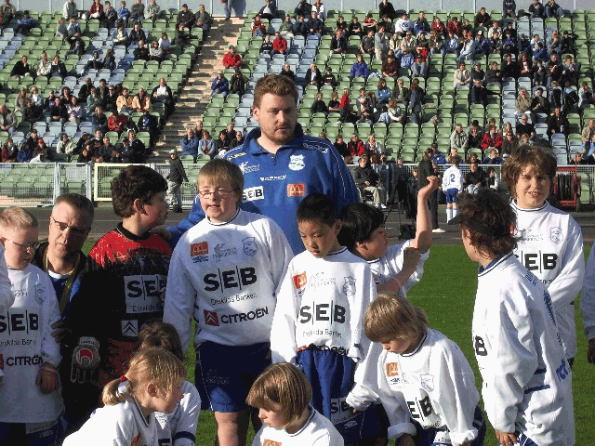

Glenn Johansson(in blue, standing in the back row) took part in the Special Olympics assistant coaching seminar. He now helps his coach with one of the junior teams at this club; here during Football Week, at a Football Festival in which the junior team were competing for the very first time. (Photo: N.Grassin, SOEE)

Glenn Johansson, 27 and Christer Reinikainen both play at Grunden Bois Football Club in Gothenburg, Sweden, a 190-strong football club for players with intellectual disabilities. They were two of the 18 players with intellectual disabilities who took part in an assistant coaching seminar organized by Special Olympics Europe/Eurasia in Bondby Denmark in April 2005. Since their return, they have helped their mentor coach, Dan Jeppsson, in coaching a junior team of players with intellectual disabilities aged 6 to 10. “Glenn and Christer are role model for the younger players because they play level A. They show a lot of fair play on the field and have a lot of patience with children. They are excellent assistant coaches,” says Jeppsson. The junior team had its first competition on occasion of the Football Festival. Behind the scene, Reinikainen and Johansson helped the team with their uniforms and equipment and guided players through the warm up and stretching exercises. “Our club has around 60 players aged 6-10. I simply could not do without assistant coaches,” Jeppsson says.

“Football is my life,” explains Reinikainen. “I play on a team, I work in “division one” Orgryte IS football club, and now, I help coach the junior team on our Special Olympics club: Grunden Bois. At the assistant coaching seminar we had in Denmark, I learnt how to prepare a training session, how to warm up the body to avoid injuries for example. But you want to hear something? I find it is rather tough to be assistant coach!! The players on the team are so young it is difficult to do the exercises well: they move all the time!!” “The players on the junior team are very young,” smiles Johansson. The most difficult is to have them stay still. During practice, there is always someone running in the opposite direction and sometimes we have too players because they all want to kick the ball at the same time. But, they love us and we love them, there is no doubt about that. My dream is to teach them an exercise that they will memorize and do well till the end: I really enjoy being an assistant coach.” Dick Last, a former national goal keeper and the current goal keeper of Orgryte IS became a close friend of Reinikainen: “Dick Last is a star, but he is also my friend. He knows I went to a seminar to become assistant coach and he supports me. His support boosts me to do my best as an assistant coach,” he said.

Amongst the celebrities present at the event, was the football giant Ralf Edström, who headed in so may goals including during the 1974 World Cup and reigned supreme in the 1970s. “Football for individuals with intellectual disabilities was made famous through a documentary shown nationwide on television. I did not know some players were assistant coaches too. In my opinion, giving players responsibilities will take hand holding at first, but soon they will grow to do much more on their own. It is important to give them reasons to believe in themselves. These are outstanding initiatives and I am proud to show my support today.”
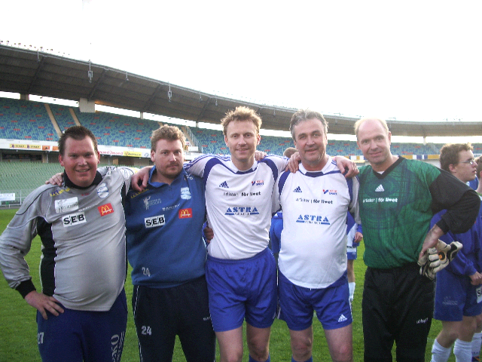
From Left to Right: Assistant coaches Christer Reinikainen and Glenn Johansson, with national football celebrities Kennet Andersson (1994 World Cup, former player for Lazzio), Ralf Edstrom (Former player for West Germany in 1974 and Swedish radio football commentator) and goal keeper Thomas Ravelli (1994 World Cup). (Photo: N.Grassin, SOEE)

